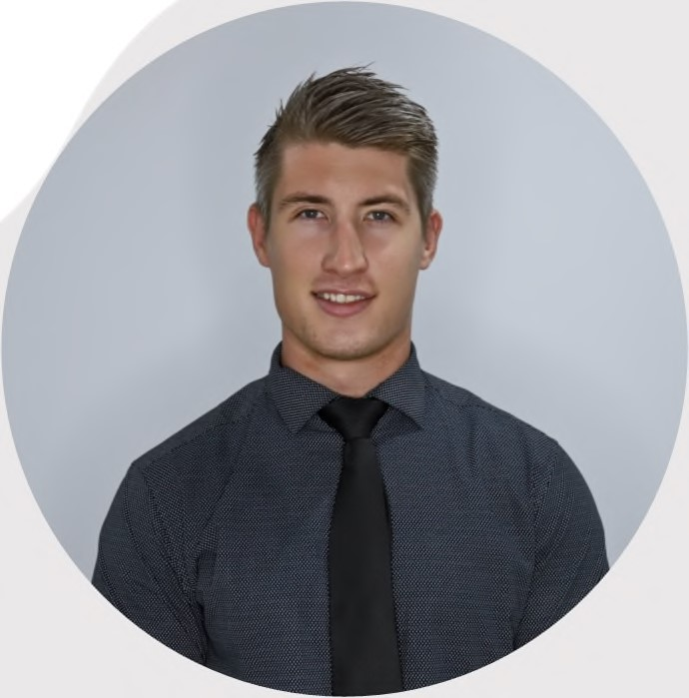
DIVANDEBRUIN

I am a dedicated and driven individual, known for my unwavering work ethic and ambition. With a mature and responsible approach, I tackle every task and challenge with utmost dedication. Throughout my university journey, I have honed exceptional time management and organizational skills, allowing me to thrive even in high-pressure situations while meeting stringent deadlines.
One of my greatest strengths lies in my ability to collaborate seamlessly within a team, contributing to a harmonious and productive work environment. Additionally, I possess a keen sense of initiative, allowing me to take charge and excel when working independently.
My commitment to excellence and self-motivation drive me to consistently deliver exceptional results. I am constantly seeking new opportunities for growth and development, eager to acquire new skills and knowledge to enhance my professional capabilities.
By leveraging my strong work ethic, adaptability, and excellent communication skills, I am confident in my ability to contribute effectively to any organization or team I am a part of. I strive for continuous improvement and always approach challenges with a positive and solution-oriented mindset.
In summary, I am a dedicated and ambitious individual who thrives under pressure, excels in both collaborative and independent work settings, and possesses a constant drive for self-improvement. With my strong work ethic and adaptability, I am well-equipped to make a positive impact in any professional endeavor.

PERSONALDETAILS
DATEOFBIRTH:
25/07/1996
ID:
9607255063086
PASSPORT:
A05109023
ADDRESS:
91
KingsleyRoad
Bluff
LANGUAGES:
English&Afrikaans
DRIVERSLICENSE:
Code8
CONTACT
PHONE:
+27606966232
EMAIL:
divan.debruin25@gmail.com
SKILLS
•
MS
Word,
Computer
Literate
–
Excel,Outlook&PowerPoint
•
Excellentcommunicationskills
•
Friendly,
courteous
&
service
oriented
•
Leadership&teamwork
•
Strongworkethic
HOBBIES
•
Gyming
•
Travelling
•
Hiking
•
Reading
WORKEXPERIENCE
PublicR elations Officer
AMSAttorneysInc
2019
–2021
Brand Ambassador
RogueModels
2015–2019
Waiter&Bartender
Lords&Legends
2014-2016
EDUCATION
TEFLFullcircle
Advanced120HoursCertificateinTeachingEnglishasaForeign
Language(TEFL)
2021
Sim Tech Training & Development Institution
BasicPlumbingCourse
2019
IIE Varsity College DurbanNorth
HonorsinManagement&Leadership
2018
IIE Varsity College DurbanNorth
BachelorofCommerce–MarketingManagement
2017
REFERENCES
CheriseJewnarain–AMSAttorneysInc
+27817153444|12
jewnch@gmail.com
TanyaCheyne–RogueModels
+27823124188
DeonLottering–Lords&Legends
+27815568280
|lottering7@hotmail.com

